Grant Harvey
harveyg3@udayton.edu
475 – Secure App Development
Dr. Phu Phung

Task 1:
i - install apache
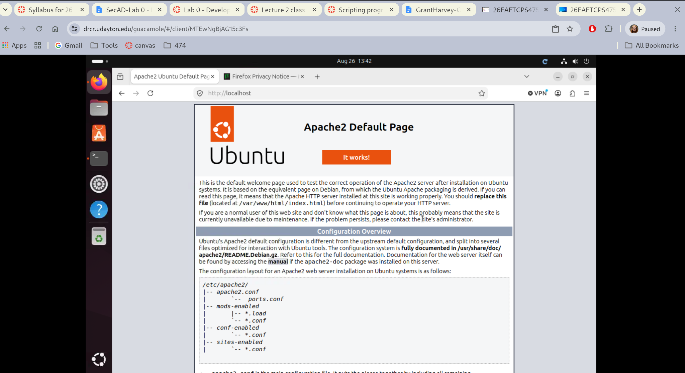

ii - install git

iii - install sublime text editor
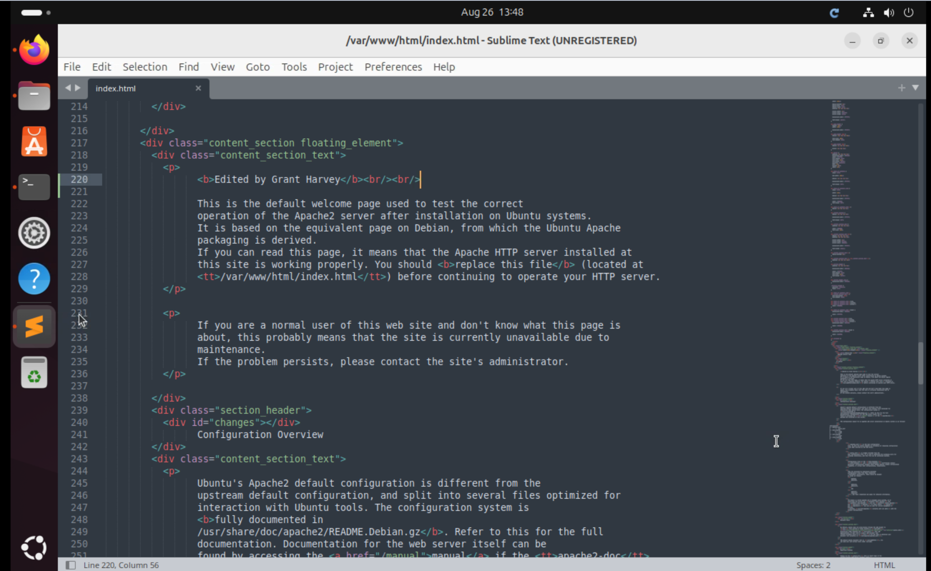

iv - install and use chrome
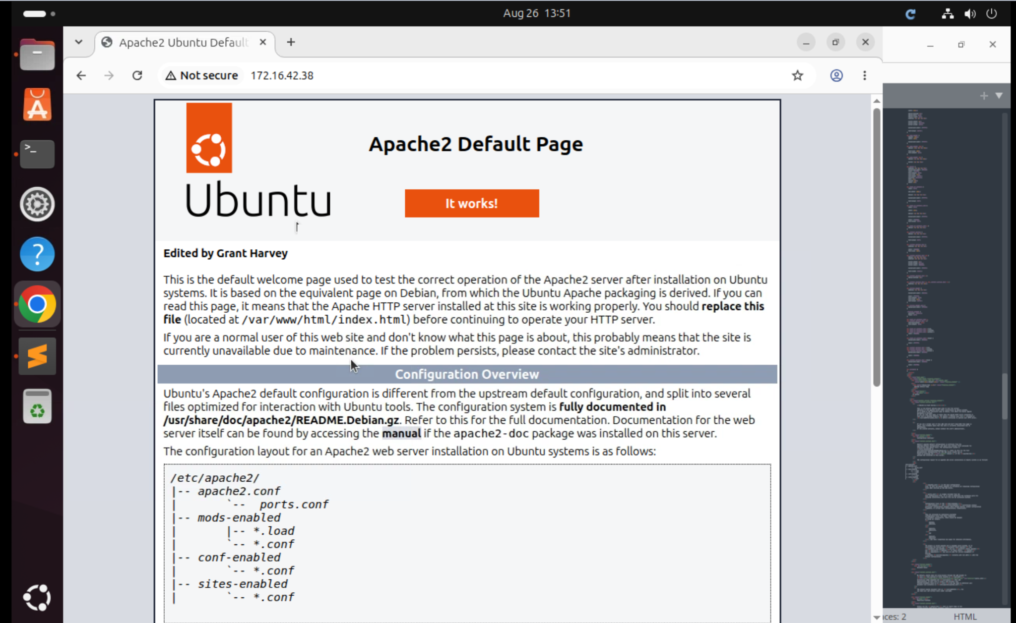

B. Networking and add name below header on index page.
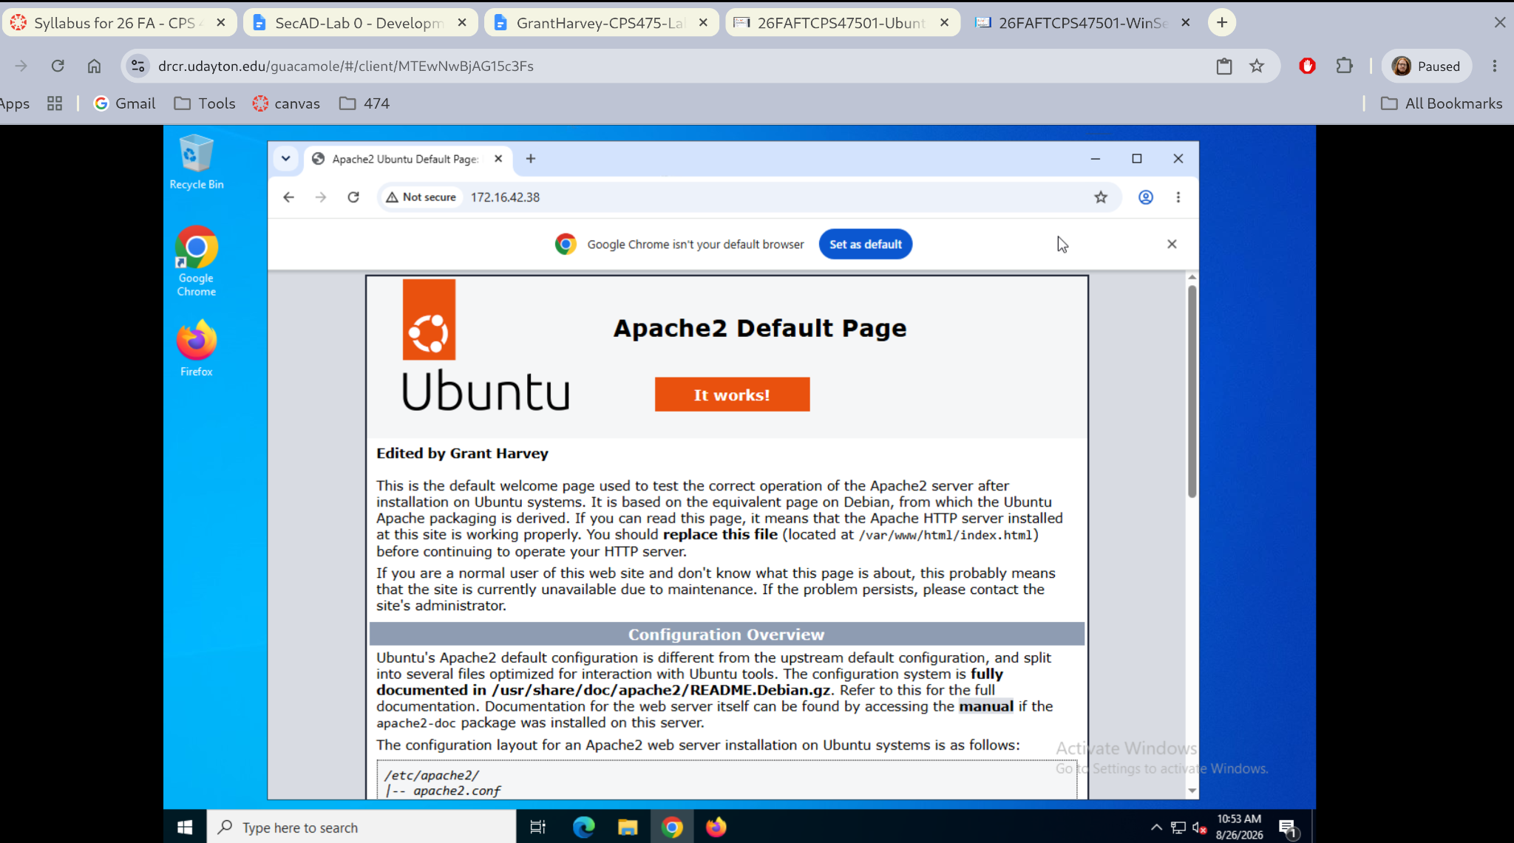

Task 2
A:
Make git repository on bitbucket and share it with professor: https://bitbucket.org/granthsrvey/secad-harveyg3/src/main/
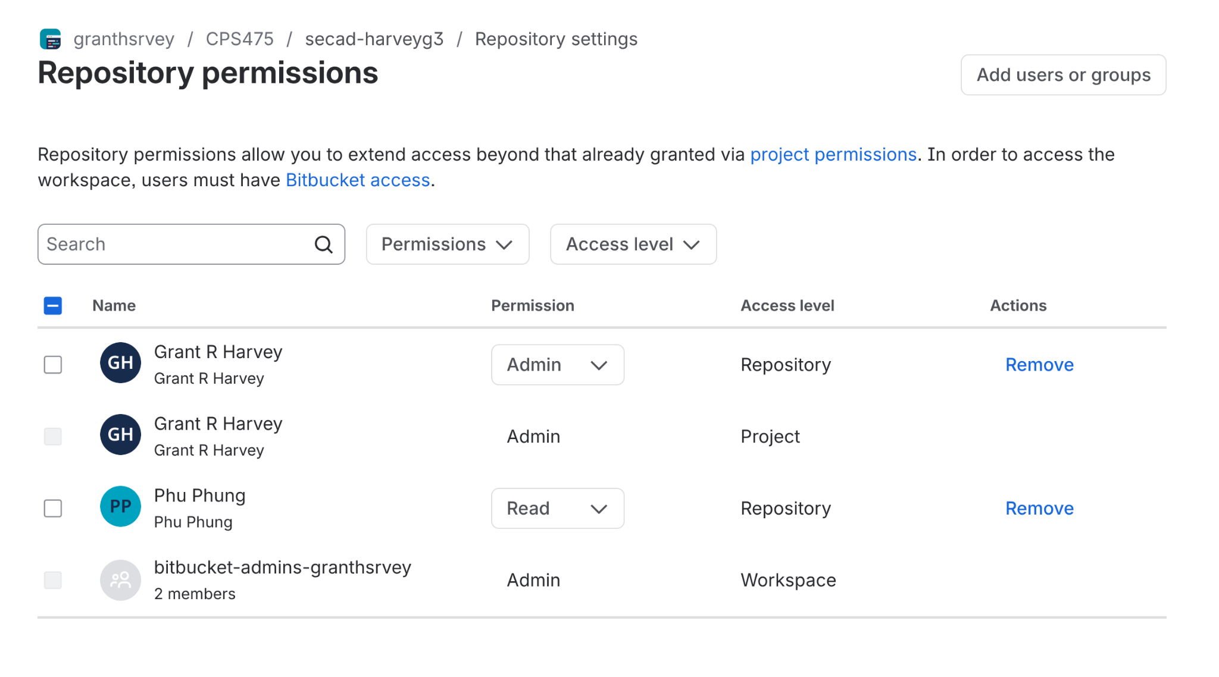
B: Clone the git repository
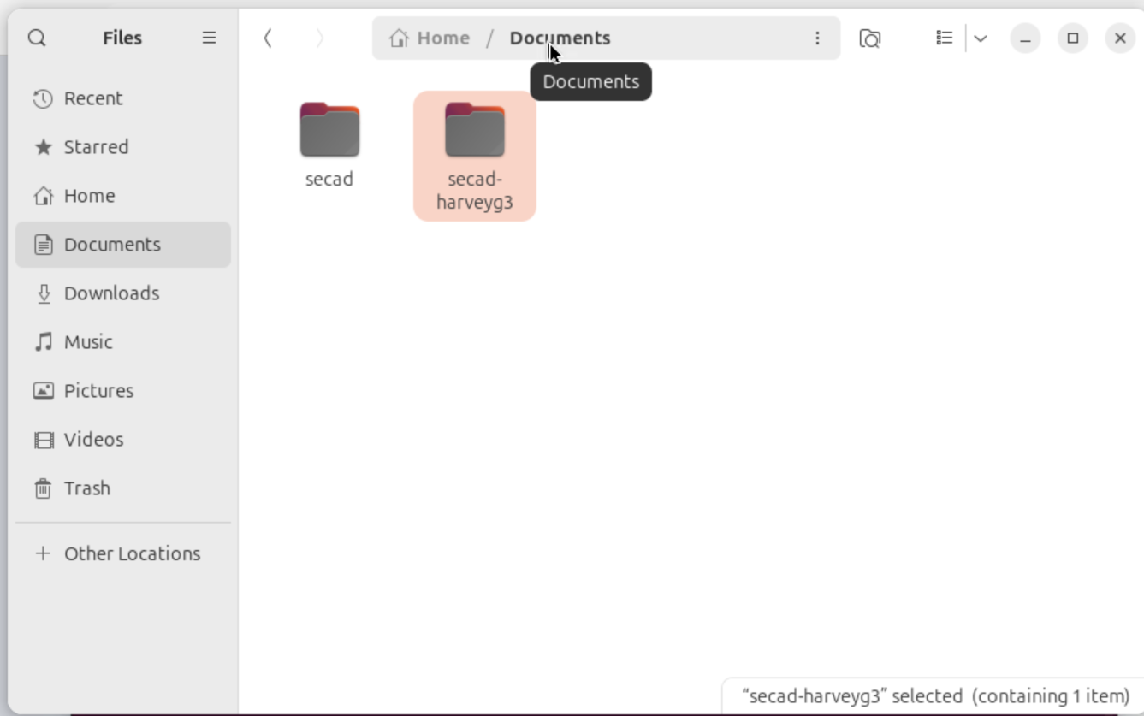
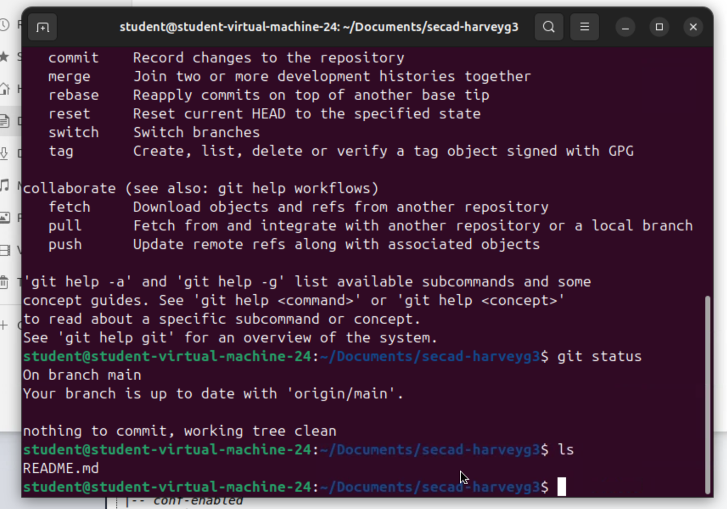

C: update the readme and push it to git
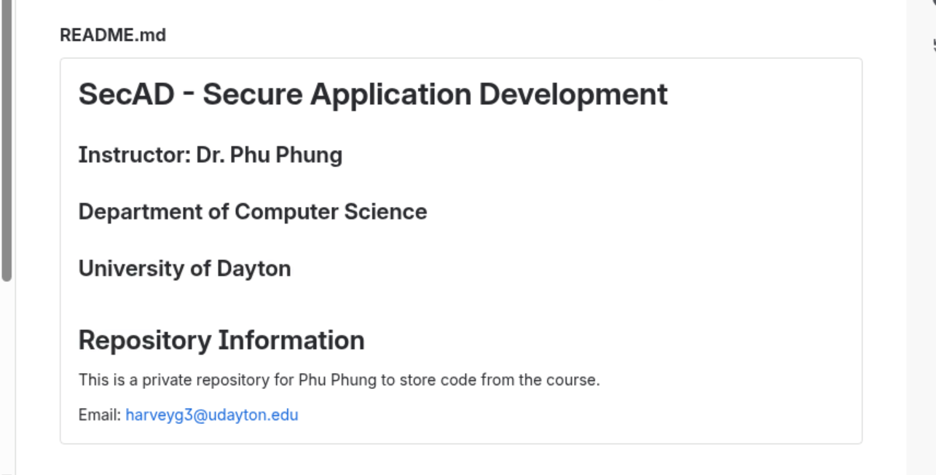

D: Clone the class repository. I did this before it said to so my screenshot shows it exist rather then the git commands to clone it
